FACULTY PROFILE
Name | THOLLA RAMA SUNKANNA | 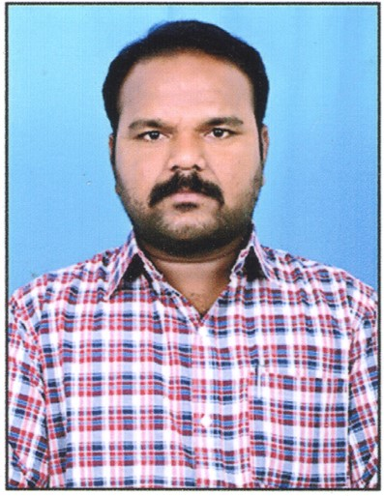
Department | PHYSICS
Designation | LECTURER
Date of Appointment | 07.06.2018
Date of Birth | 18.03.1986
Contact Number | +919052255621
Email Id | thollaramasunkanna@gmail.com
Academic qualifications:
Qualification | Name of the University | Year of passing
Ph. D | - | -
M.SC/M.A/M.COM | SV University | 2010
Others Qualifications (NET/SET etc.), if Any | AP-TS SET – 2014 (OU)  UGC CSIR NET – 2017 | 2014  2017
Experience Details:
Designation | Name of the Institution, Place | From | To
Lecturer | Government Degree College: Gummalakshmipuram | 07.06.2018 | 28.09.2022
Lecturer | Government Degree College: Salur | 29.09.2022 | 02.08.2023
Lecturer | S.V.A Government College (M); Srikalahasti | 03.08.2023 | Till date
Total Teaching Experience: P.G Classes: 0 Years
U.G Classes: 5 Years.
Research Experience Including Years spent in M.Phil/Ph.D: Nil
Fields of Specializations under the subject/Discipline:
a.Condensed Matter Physics.
b.
List of research Publications/Books:
Title of the Paper | Journal | Year of Publishing | UGC CARE/SCI/SCOPUS etc.
NIL
List of Projects Completed:
Title of the Project | Sponsoring Agency | Major/Minor | Total Grant Received | Year of Completion
NIL
List of OC/RC/TOTs/FDP/MOOCS/ARPIT Attended:
Title of the course | Type of the Course (FDP/RC Etc.) | Duration | Organized by
Child Protection & Child Rights in Disasters and Emergencies | Training of Trainers | 4 days  (14 to 17 Nov -2023) | CCDRR - NIDM
Microsoft Diversity Skilling Program | Online Facilitator Training Program on AI Fluency,Digital Productivity, and Employability Skills | 5 days (18-12-2023 to 22-12-2023). | APITA
One Day Training of the Trainers Programme (ToT) on UNESCO-MGIEP SEEK & SEL Certificate Course | SEEK & SEL Certificate Course | 01 day (23.01.2024) | UNESCO - MGIEP
Co-Curricular, Extension and Professional Development Related Activities:
S.No | Name of the Activity | Details
1 | Student related Co- Curricular, extension and field-based activities (such as extension work through NSS/NCC and other channels, Cultural activities, subject related events and counseling. | Educational Tour – NARL, Gadanki  Field Trip – 33/11 Sub Station - Srikalahasti
2 | Contribution in corporate life and management of the department and participation in academic and administrative committees and responsibilities and Professional Development. | Member of the Special Fee Committee  Member of the Attendance Committee  Member of the Audio – Visual Committee  Member of the Time table Committee  Member of the Online Teaching Learning Process CCE  Mentor for Long Term Internship (4 Months)  Mentor for Short Term Internship (2 months)
Awards/ Achievements: Please give details of any other credentials, significant contributions, awards received:
S.No | Name of the Award/Achievement | Date of Receiving
1 | Nil

